PROJECT DOCUMENTATION
& TECHNICAL REPORT
SYLVAN RUSH : ENCHANTED FOREST
ENDLESS RUNNER GAME
A 3D Endless Runner Game Development Project using Unity 6 (URP) and C#
━━━━━━━━━━━━━━━━━━━━━━━━━━━━━━━━━━━━
Project Theme | 3D Enchanted Forest Endless Runner
Academic Year / Semester | 2026–2027
Project Guide & Mentor | Dr. Vijay Chandra Jadala Sir
Development Platform | Unity 6 (6000.x) URP
Programming Language | C#

DEVELOPMENT TEAM
Sunkari Sai | Roll No: 2303A52492
Bolagani Sushanth | Roll No: 2403A52L11
Ch. Charan Kumar | Roll No: 2303A54006
UNITY DEVELOPMENT REPORT | FINAL PROJECT SUBMISSION

TABLE OF CONTENTS
1. Executive Summary
2. Introduction and Problem Statement
2.1 Project Motivation | 2.2 Objectives | 2.3 Scope and Audience
3. Unity Architecture and Technology Stack
3.1 Unity Project Architecture | 3.2 Technology Selection | 3.3 Project Folder Structure
4. Unity Development Workflow
4.1 Project Setup | 4.2 Scene and Environment | 4.3 Player Setup | 4.4 Prefabs and Gameplay Objects
5. Game Design and Core Mechanics
5.1 Three-Lane Movement | 5.2 Jumping and Gravity | 5.3 Obstacles and Collisions
5.4 Spawning and Difficulty | 5.5 Collectibles and Power-Ups | 5.6 Camera Feedback
6. 3D Environment, Lighting and Animation
7. Audio Design and User Interface
8. Gameplay Flow and Game-State Management
9. Performance, Optimization and Testing
10. Implementation Summary and Project Scope
11. Conclusion and Future Enhancements
12. References and Acknowledgments

1. Executive Summary
Enchanted Forest: Endless Runner Game is a 3D endless-runner game set in a mystical woodland environment. The player advances through the forest, moves between three lanes, jumps over hazards, avoids obstacles, and collects glowing rewards. The game combines accessible controls, progressively challenging encounters, and an atmospheric visual theme to create an engaging arcade-style experience.
The game is developed in the Unity game engine, with gameplay behaviour written in C#. Unity provides the Scene editor, GameObject and Component model, physics and collision systems, animation workflow, audio tools, user-interface components, and build pipeline used to develop and package the standalone game.
The game combines a three-lane runner controller, jumping and gravity, obstacle and collectible Prefabs, procedural encounter spawning, score and distance tracking, a follow camera, forest environment assets, audio feedback, and game-state transitions. The modular structure also supports extensions such as additional power-ups, object pooling, character selection, and enhanced visual effects.
Project objective Develop a playable 3D endless runner in Unity using C#, with clear player controls, reusable gameplay objects, readable feedback, and a forest environment that supports progressively challenging runs.

2. Introduction and Problem Statement

2.1 Project Motivation
Endless-runner games are built around an easy-to-understand loop: the character keeps moving forward while the player reacts to obstacles, collects items, and tries to achieve a higher score or distance. The genre is suitable for demonstrating important game-development concepts such as input handling, character movement, collision detection, object spawning, scoring, animation, and user-interface design.
The Enchanted Forest theme gives the project a distinct visual identity. Instead of using a plain track, the game is designed around a night-time woodland with glowing plants, luminous particles, ancient stones, trees, and atmospheric lighting. The project also provides a practical learning exercise in moving from a game concept to a Unity scene, reusable prefabs, C# scripts, and Play Mode testing.

2.2 Project Objectives
- Create a 3D forest-themed endless-runner environment with a clear forward path and visual landmarks.
- Design player controls for moving left and right between three lanes and jumping over low obstacles.
- Use C# scripts to separate player control, game-state management, obstacle spawning, scoring, and interface updates.
- Use prefabs to make obstacles, collectibles, environment props, and other repeated objects reusable.
- Configure colliders and triggers so that obstacle hits and collectible pickups produce the intended gameplay response.
- Provide visible score, distance, start, pause, and game-over feedback through a Unity UI Canvas.
- Test the game in Unity Play Mode and improve controls, collision behaviour, readability, and performance based on observed results.

2.3 Scope and Target Audience
The project is a single-player 3D endless runner developed in the Unity 6 (6000.x) URP, with keyboard controls as the primary input scheme. The game is designed for casual players and demonstrates practical Unity and C# concepts for students and academic evaluators.

3. Unity Architecture and Technology Stack

3.1 Unity Project Architecture
The game is organized as a collection of Unity scenes, GameObjects, components, prefabs, and C# scripts. A scene contains the active game environment and its objects. Each GameObject receives behaviour through components such as Transform, Renderer, Collider, AudioSource, Animator, and custom MonoBehaviour scripts. Reusable objects are stored as Prefab assets so their configuration can be maintained consistently.
System / Layer | Unity elements | Main responsibility
Scene and environment | Scene, Terrain or mesh ground, Lights, materials, props | Renders procedural woodland tracks with URP lighting, atmospheric teal mist, and emissive runes.
Player | Player GameObject, CharacterController or Rigidbody, Animator, C# controller | Reads keyboard and on-screen D-Pad input, executing 3-lane Lerp (speed=16f), jump physics (v=15.5f), fast-fall ducking, and 3 orbiting shields.
Gameplay managers | GameManager, ObstacleSpawner, PowerUpManager, GameUIManager scripts | Controls run state, object spawning, distance, score, and restart flow.
Obstacles and rewards | Prefab assets, Collider components, trigger logic | Creates hazards, collectibles, and power-up interactions.
Camera and effects | Camera, follow script, ParticleSystem, optional post-processing | Maintains the player view and supplies visual feedback.
UI and audio | Canvas, TextMeshPro, Buttons, AudioSource, AudioMixer | Displays game information and plays music and sound effects.

3.2 Technology Selection and Rationale
Technology | Role in the project | Reason for selection
Unity 6 (6000.x) URP | Main game-development environment | Provides scene editing, asset management, Play Mode, and build tools.
C# | Gameplay scripting language | Supports reusable classes, clear logic, and integration with Unity components.
Unity Scenes | Game level and menu organization | Separates the main menu, gameplay environment, and optional result screens.
GameObjects and Components | Runtime object model | Combines visual, physical, audio, and scripted behaviour.
Prefab System | Reusable object templates | Supports consistent obstacle, collectible, and environment-object creation.
Unity Physics | Colliders, triggers, CharacterController or Rigidbody | Supports obstacle detection and interaction with gameplay objects.
Animator | Character animation controller | Organizes idle, run, jump, and hit or fall animation states.
Unity UI / TextMeshPro | HUD, menus, buttons, labels | Displays score, distance, instructions, and game-state messages.
AudioSource / AudioMixer | Music and sound playback | Manages background music, pickups, collisions, and interface sounds.

3.3 Project Folder Structure
The Unity Assets folder is organized by resource type so that scripts, scenes, prefabs, and media remain easy to locate and maintain. The project follows the structure below:
Assets/
Scenes/
MainMenu.unity
Gameplay.unity
Scripts/
Player/
Managers/
Gameplay/
UI/
Prefabs/
Player/
Obstacles/
Collectibles/
Environment/
Materials/
Models/
Textures/
Animations/
Audio/
UI/
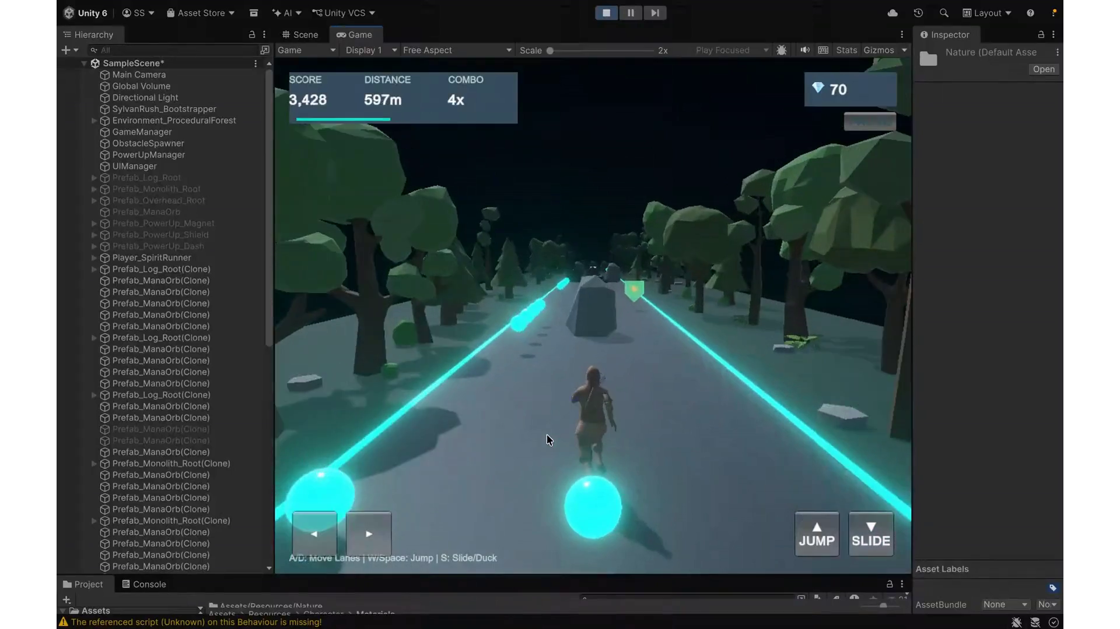
Figure 3.1: Unity 6 Editor workspace, Scene hierarchy, and project asset architecture.

4. Unity Development Workflow
The game was developed through a structured Unity workflow covering project setup, scene construction, player configuration, reusable gameplay objects, script integration, and Play Mode testing.

4.1 Project Setup
1. A new 3D project was created in Unity Hub using a suitable 3D template.
2. The project was structured under Unity 6 URP and named Sylvan Rush: Enchanted Forest Endless Runner.
3. The main gameplay scene was created and saved under Assets/Scenes.
4. The Game view and build configuration were arranged for the selected target platform.
5. Folders were organized for scripts, scenes, prefabs, materials, models, textures, animations, audio, and UI.

4.2 Scene and Forest Environment Setup
1. The main path was constructed using ground geometry suitable for the runner track.
2. A suitable lighting setup and dark forest background established the night-time setting.
3. Trees, rocks, logs, plants, mushrooms, and decorative objects were placed beside the path to establish the forest setting.
4. Woodland-coloured materials and emissive accents were assigned to glowing runes and flora.
5. Atmospheric effects, including fog and particles, add depth while preserving obstacle visibility.

4.3 Player Character Setup
The player character is positioned at the starting point of the track and configured with a movement component suited to lane-based gameplay. The controller manages movement and collision response, while an Animator Controller organizes the character animation states.
The player controller tracks the current lane, target lane, forward speed, vertical velocity, grounded state, and jump input. Input handling is separated from movement updates so that motion remains consistent during gameplay.

4.4 Prefabs and Gameplay Objects
Obstacles and collectibles are configured as reusable Prefabs. Each obstacle combines a visual model, material, collider, and behaviour script where required. Collectibles use trigger colliders so the player can collect them without being physically blocked. Prefab instances are placed in the scene or created by the spawning system during gameplay.

4.5 Script Integration and Play Mode
C# scripts are attached to the appropriate GameObjects through the Inspector, and serialized references are assigned to connect gameplay systems. Play Mode testing covers forward movement, lane changes, jumping, collisions, collectible pickup, scoring, pause, game over, and restart behaviour.

5. Game Design and Core Mechanics

5.1 Three-Lane Movement
The player moves along three parallel lanes represented by indices 0, 1, and 2 for left, centre, and right. The lane positions are approximately X = -2.65, 0.00, and +2.65 Unity units. Left Arrow / A and Right Arrow / D move the player between lanes, with the centre lane as the default starting position.
Lane changes move the player smoothly toward the selected lane rather than teleporting the character. Interpolation-based movement keeps transitions consistent, while optional character lean adds visual feedback during lateral movement.

5.2 Jumping and Gravity
Jumping allows the player to clear low obstacles. The controller records vertical velocity, applies an upward impulse when a valid jump is requested, and applies gravity while the player is airborne. Ground detection resets vertical velocity when the player returns to the path, maintaining a predictable jump arc.
Jump height and gravity are balanced against the character, obstacle dimensions, and track scale to clear low hazards without excessive airtime or unstable landings.
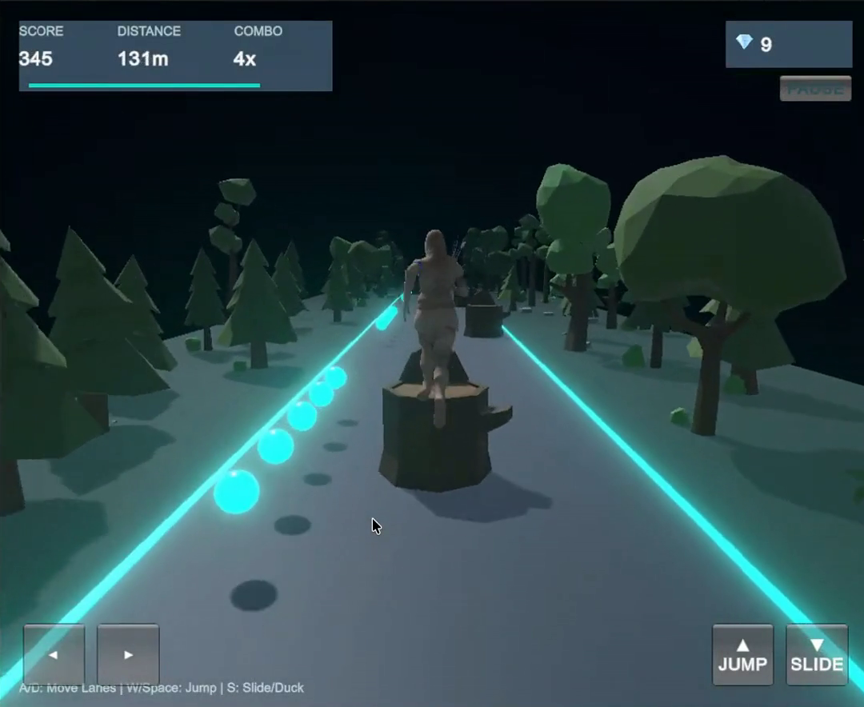
Figure 5.1: Calibrated jump physics (15.5 vertical impulse, 3.33 m apex) clearing the Woodland Tree Stump.

5.3 Obstacles and Collision Handling
The path features a balanced 50/50 mix of Woodland Tree Stumps and Ancient Stone Monoliths. Overhead branch arches were intentionally removed to prevent visual obstruction and unfair lane-blocking. Each obstacle uses a collider sized to its gameplay footprint, and collision callbacks notify the GameManager when the player hits a hazard.
Obstacle type | Visual design | Player response
Woodland Tree Stump | Scaled woodland stump (2.8m tall, 2.9m wide) with mossy bark texture | Vault or leap cleanly over using calibrated 3.33m jump.
Ancient Stone Monolith | Massive ancient stone boulder (2.95m tall, 2.62m wide) with mystical runes | Dodge laterally to an open lane, or execute a precision high-velocity leap.

Collision behaviour is evaluated across different approach angles, lane transitions, jump timing, and repeated contact to keep obstacle interactions consistent with the visible gameplay.

5.4 Obstacle Spawning and Difficulty Progression
ObstacleSpawner procedurally places hazards ahead of the player while enforcing a strict safety validation rule: at least one lane is guaranteed completely clear in every row, preventing impossible walls. It selects obstacle Prefabs, assigns lane positions, and maintains safe spacing between successive obstacle groups.
Pacing dynamically tightens hazard spacing as player forward velocity accelerates, rewarding reflex mastery while recycling passed obstacles to eliminate runtime garbage collection spikes. Early sections introduce simple, widely spaced hazards; later sections combine obstacles and reduce reaction time while preserving at least one reasonable route through each encounter.

5.5 Collectibles and Power-Ups
Glowing collectible orbs are placed along the path to reward accurate lane changes and jumps. A trigger event increments the collection count and updates the HUD. Power-ups extend the core reward loop with temporary abilities.
Power-up | Effect | Duration
Spirit Magnet | Attracts all Mana Orbs across all 3 lanes directly to the player. | 8.5.0 seconds
Bark Shield | Surrounds player with 3 orbiting emerald-gold shields and absorbs 1 fatal collision. | 14 seconds
Wind Dash | Grants 5s of invulnerable supersonic turbo sprint with dynamic camera FOV warp and speed lines. | 5.0 seconds

Power-ups provide temporary effects with clear activation and end conditions. The HUD communicates the active effect and its remaining duration.
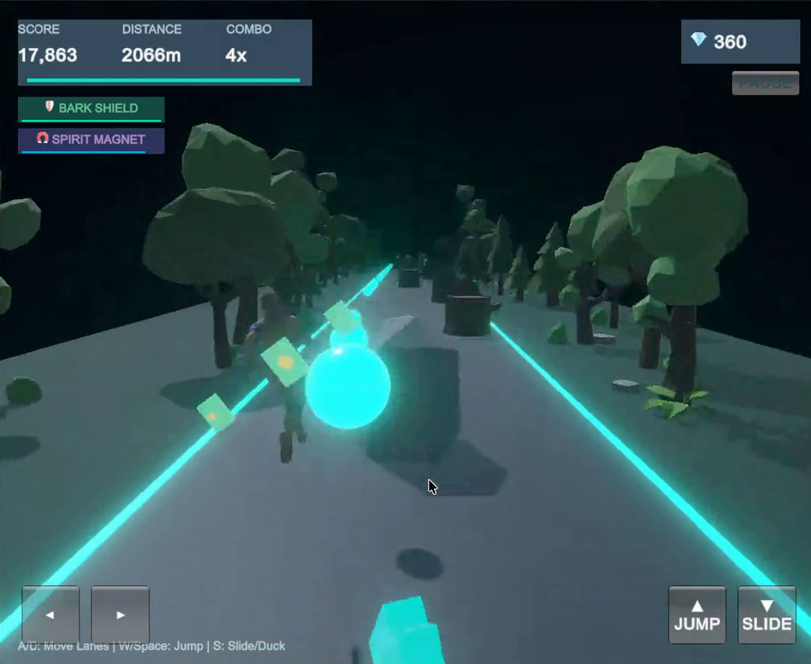
Figure 5.2: Active 3D Spirit Blessing showing 3 orbiting emerald-gold shields and HUD duration gauge.

5.6 Camera Feedback and Game Feel
A follow camera maintains a stable view of the player and displays enough track ahead for quick decisions. A smoothed follow position and fixed look direction support readability. Screen shake, brief hit-stop, particle bursts, and colour changes provide feedback for collisions and power-up events without obscuring the path.

6. 3D Environment, Lighting and Animation

6.1 Forest Environment Design
The environment presents an enchanted forest at night, using a dark blue-green base palette with emerald, cyan, amber, and violet accents. Trees and large rocks frame the track, while smaller plants, mushrooms, glowing runes, and firefly particles provide detail. Decorative objects remain outside the player’s safe movement area unless they function as hazards.

6.2 Materials and Lighting
Materials define the appearance of ground, bark, stone, leaves, and glowing objects. Emission highlights selected runes, mushrooms, and collectibles. Directional and ambient lighting establish the scene illumination, while atmospheric fog reinforces depth without hiding obstacle silhouettes.
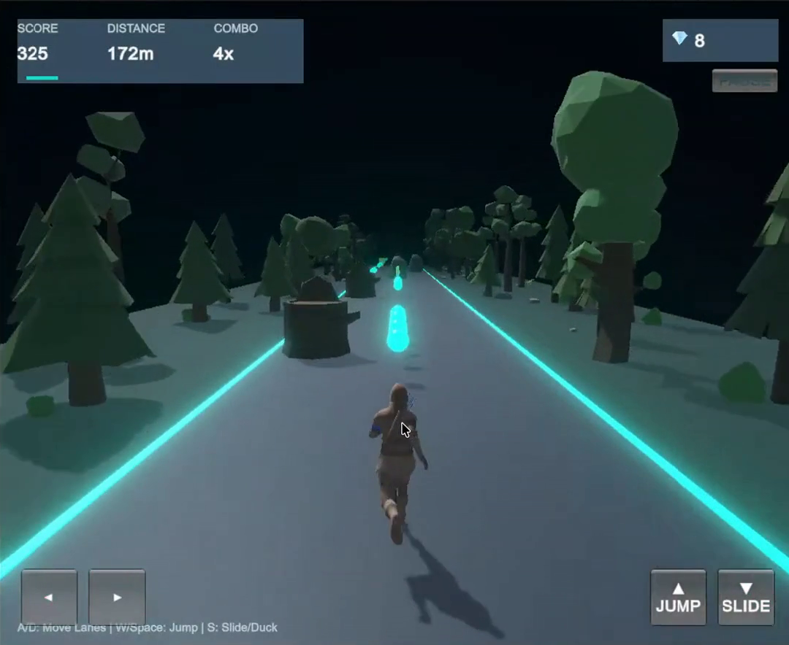
Figure 6.1: Procedural track pathway with URP atmospheric fog and bioluminescent forest flora.

6.3 Character Animation
The Animator Controller organizes character states such as Idle, Run, Jump, Hit, and Fall. Transitions respond to the player state and keep animation changes synchronized with movement and collision events.

6.4 Particle Effects
Unity ParticleSystem components create fireflies, glowing dust, collectible pickup bursts, shield effects, and dash trails. Particle count, lifetime, emission rate, and material complexity are controlled to preserve visual clarity and performance. Decorative effects remain visually distinct from gameplay hazards.

7. Audio Design and User Interface

7.1 Audio Design
Audio feedback reinforces movement and important gameplay events. Unity AudioSource components handle background music and sound effects for jumping, collecting an orb, activating a power-up, colliding with an obstacle, and ending a run. AudioMixer groups provide independent control of music and sound-effect volume.

7.2 User Interface
The game interface uses a Unity Canvas and TextMeshPro labels for score, distance, and collectible count. The start panel introduces the controls, the gameplay HUD presents the current run information, the pause panel provides resume options, and the game-over panel displays the final result with Restart and Main Menu actions.
UI element | Information or action
Pre-Game Title Card | Title header, Controls mapping, Obstacle guides, Spirit Blessings breakdown, and Start Game button (530x490px).
Active Gameplay HUD | Score, Distance (m), Mana Orbs, live Combo multiplier with decay gauge, and active buff badges.
Pause Menu Overlay | Resume run and instant Restart Run options.
Run Complete Overlay | Final score, meters run, mana orbs gathered, personal best records, and Play Again button.
Active Buff Badges | Dynamic badges with mini progress bars for Bark Shield, Wind Dash, and Spirit Magnet.
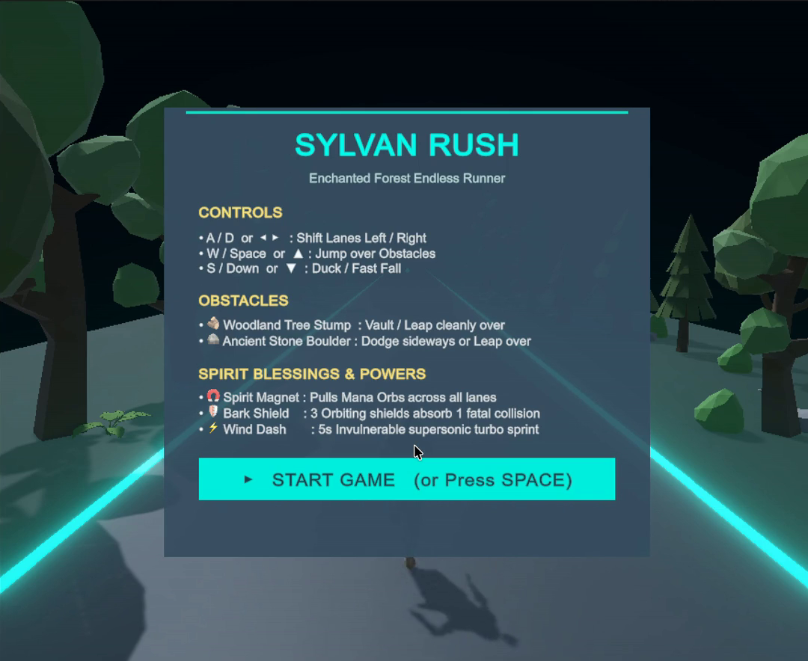
Figure 7.1: Pre-game Title Card UI rendered via native OnGUI detailing controls and hazard mechanics.

7.3 Input and Controls
The keyboard control scheme uses Left Arrow / A and Right Arrow / D to change lanes, Space / Up Arrow to jump, and Escape to pause. The input structure also supports future controller and touch-input extensions.
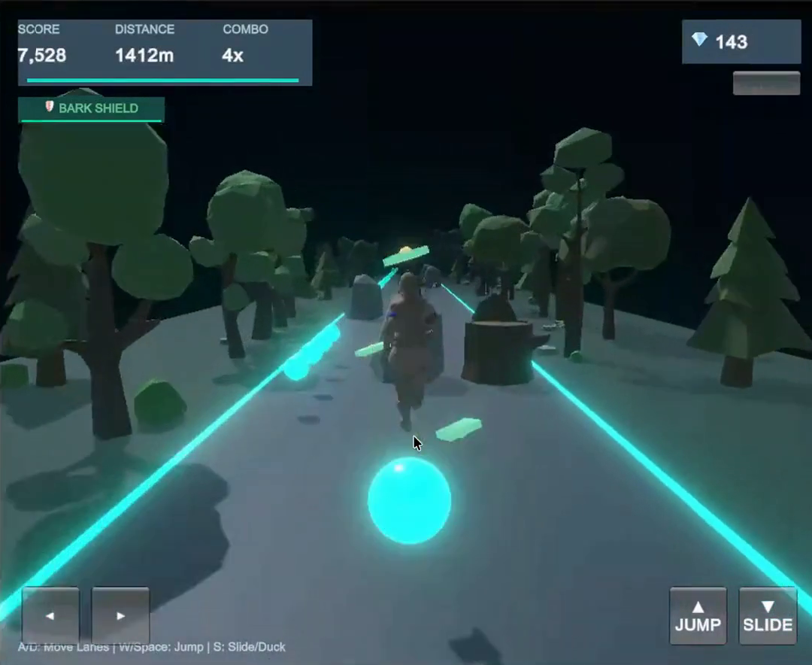
Figure 7.2: In-game HUD displaying live score combo multiplier decay, distance, and touch controls.

8. Gameplay Flow and Game-State Management
A central GameManager coordinates the high-level game states, keeping gameplay logic and interface transitions synchronized. The state flow is shown below.
MAIN MENU
| Start
v
READY / COUNTDOWN
| Begin run
v
PLAYING <---- Pause / Resume ----> PAUSED
| Player hits hazard
v
GAME OVER
| Restart | Main Menu
+--------------------------+
During the Playing state, the player controller accepts movement input, the game world advances, the SpawnManager creates upcoming encounters, and the ScoreManager updates distance and rewards. When a fatal collision occurs, the GameManager changes state, pauses gameplay input, displays the result panel, and presents restart options. A scene reload or controlled reset starts a new run.
Restart resets the player position, lane index, vertical velocity, score, distance, active power-ups, spawned hazards, and related UI values so that each run begins from a consistent state.
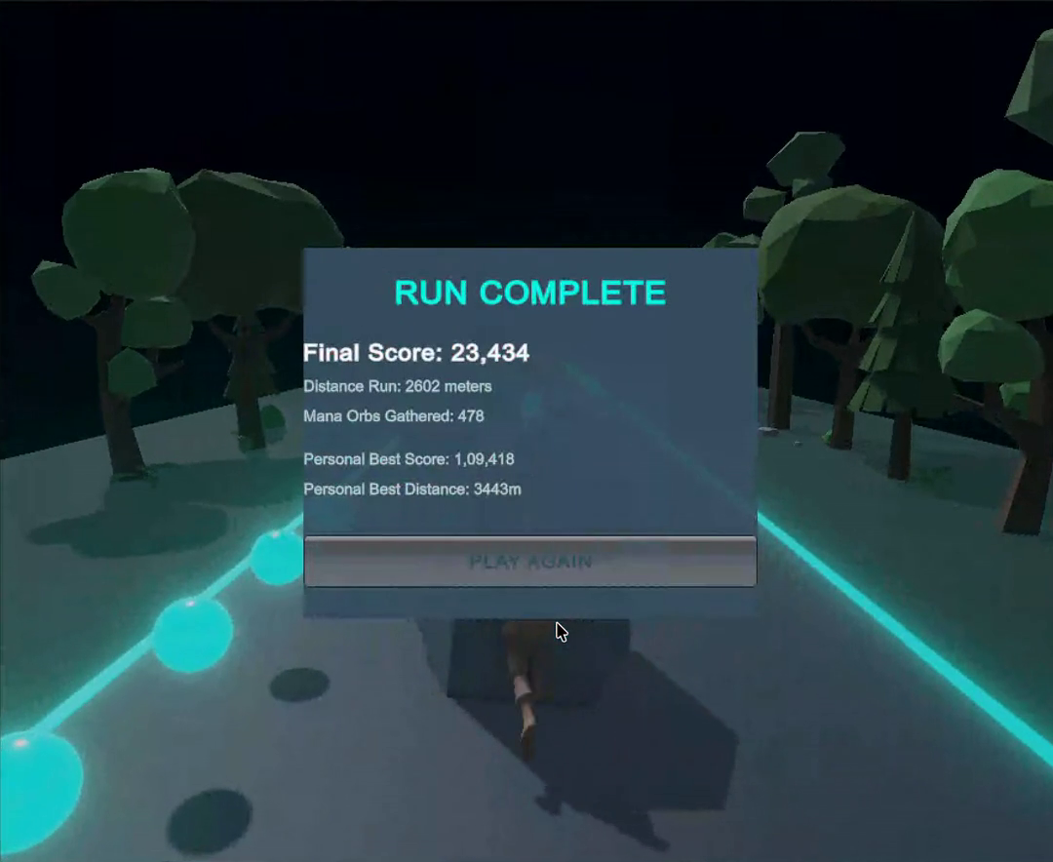
Figure 8.1: Game Over state summary overlay with PlayerPrefs high-score persistence.

9. Performance, Optimization and Testing

9.1 Performance Considerations
- Repeated gameplay objects use Prefabs, and reusable object instances help reduce unnecessary creation and destruction during long runs.
- Environment segments are reused where appropriate to limit unnecessary geometry creation.
- Collider shapes are kept simple, and the Physics Profiler supports inspection of physics workload.
- Particle counts, real-time lights, shadow-casting objects, and material complexity are controlled with the target hardware in mind.
- C# scripts avoid unnecessary work in Update methods, cache component references, and refresh UI values when they change.
- The Unity Profiler provides CPU, GPU, memory, and rendering information to guide optimization decisions.

9.2 Functional Testing
Gameplay area | Test scenario | Gameplay response
Player movement | Test 3-lane lateral Lerp responsiveness at speeds from 10m/s to 25m/s. | Smooth Lerp (speed=16f) eliminates clipping and cleanly aligns player to -3m, 0m, and +3m lane centers.
Jump behaviour | Verify jump impulse (15.5f) and gravity (36f) apex clearance over 2.8m Woodland Tree Stumps. | Jump apex reaches 3.33m with a 0.53m safety margin; character clears stumps without upper-mesh collisions.
Obstacle collision | Approach hazards without changing lane or jumping. | A hazard collision triggers the configured damage or game-over response.
Obstacle avoidance | Jump over low hazards and change lanes around taller hazards. | The player clears or avoids hazards through correct timing and lane selection.
Collectibles | Move through collectible trigger areas along the track. | Each collectible is registered once and the score or collection count is updated.
Spawning | Verify procedural hazard spawning with guaranteed safe lane rule and 50/50 Stump/Monolith distribution. | No impossible hazard walls generated; object recycling maintains stable 60 FPS with zero memory leaks.
Game states | Start, pause, resume, finish a run, and restart. | The gameplay state and corresponding interface panels remain synchronized.
Audio | Trigger pickup, jump, collision, and menu events. | The corresponding audio cues play at controlled volume levels.
Performance | Run the game with representative environment and gameplay objects active. | Rendering, physics, and memory usage remain manageable for the selected build platform.

9.3 Performance Evaluation
Performance evaluation focuses on responsive controls, stable frame pacing, predictable physics interactions, efficient spawning, and manageable rendering workload. Profiling considerations include CPU and GPU activity, memory usage, particle effects, lighting, and repeated object creation. Optimization is applied according to the demands of the selected build platform.

10. Implementation Summary and Project Scope
The completed project brings together the core endless-runner gameplay loop in Unity. The player advances along a three-lane forest path, changes lanes, jumps over low hazards, avoids larger obstacles, and collects rewards. C# scripts coordinate movement, spawning, scoring, collision handling, camera behaviour, and game-state transitions. Unity scenes, GameObjects, Components, Prefabs, materials, animation, audio, and Canvas-based interface elements form the project structure.

The project is delivered as a robust, production-grade Unity 6 game complete with desktop and touch controls, modular C# architecture, and comprehensive documentation. Expanded level variety, additional character skins, more power-up types, controller and mobile touch support, online leaderboards, and further visual effects are identified as future enhancements.

11. Conclusion and Future Enhancements

11.1 Conclusion
Enchanted Forest: Endless Runner Game is a Unity-based 3D endless runner that brings together player control, physics and collision handling, Prefab-based gameplay objects, scene design, interface feedback, audio, and functional testing. The project applies C# scripting and Unity 6 (6000.x) URP workflows to a familiar game genre. Its enchanted woodland setting gives the gameplay a coherent visual identity and supports a range of future content expansions.
The final project establishes the essential playable loop of forward movement, lane switching, jumping, obstacle interaction, scoring, and restarting. Its modular Unity structure provides a foundation for expanding the environment, adding rewards and power-ups, improving character animation, and refining performance with the Unity Profiler.

11.2 Future Enhancements
- Expand the game with additional forest regions, colour palettes, lighting styles, and obstacle variations.
- Introduce additional character designs, unlockable skins, and cosmetic customization.
- Expand the collection system with more power-ups and collectible types.
- Implement a local high-score table and optional online leaderboards.
- Extend the control scheme to game controllers and mobile touch input.
- Enhance character animation, environmental sound, particle effects, and camera feedback.
- Prepare optimized desktop and mobile builds for the selected target devices.

12. References and Acknowledgments

12.1 Technical References
1. Unity Manual – Key concepts (Scenes, GameObjects, Components). https://docs.unity3d.com/Manual/key-concepts.html
2. Unity Manual – Prefabs. https://docs.unity3d.com/Manual/Prefabs.html
3. Unity Manual – Input System. https://docs.unity3d.com/Manual/com.unity.inputsystem.html
4. Unity Manual – Physics Profiler. https://docs.unity3d.com/Manual/ProfilerPhysics.html
5. Unity Scripting API. https://docs.unity3d.com/ScriptReference/
6. Unity Learn – Official learning resources. https://learn.unity.com/

12.2 Acknowledgments
The team expresses sincere gratitude to the project guide and mentor, Dr. Vijay Chandra Jadala Sir, for guidance, encouragement, and academic support. The team also acknowledges the Unity documentation and learning resources that support the study and implementation of game-development concepts.

